**CLOUD FORMATION ASSIGNMENT**

**1.**Click on cloud formation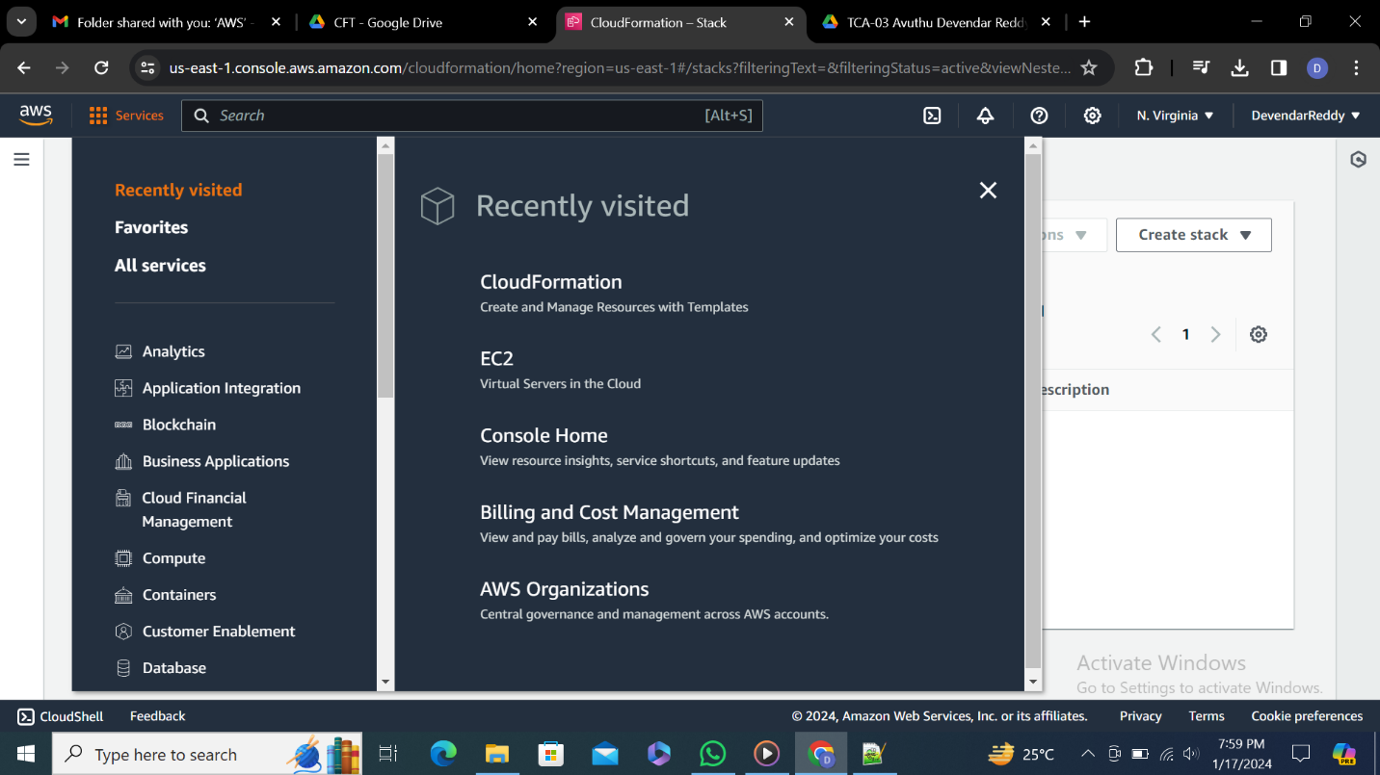

**2.**Click on create stack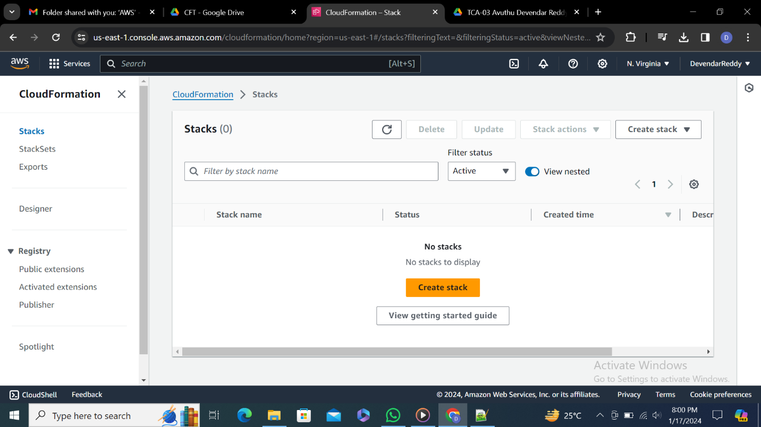

**3.**Template must be Jason or yaml file and make sure template is ready and upload a template file

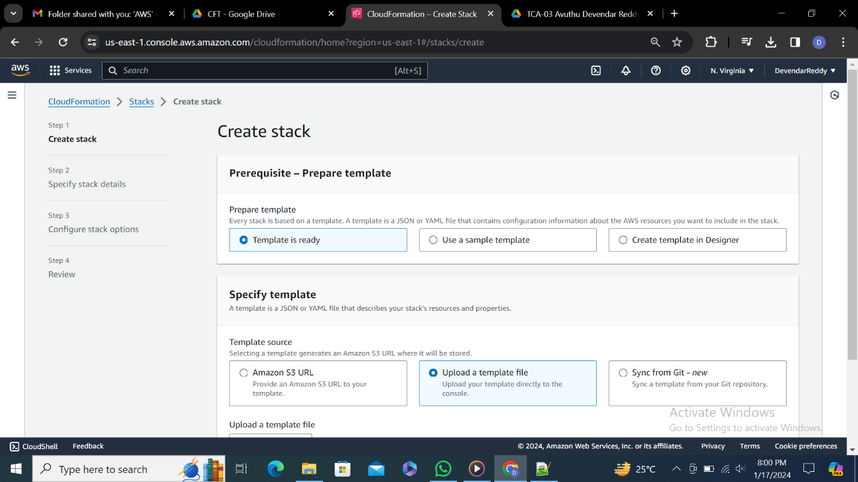

**4.**This is the template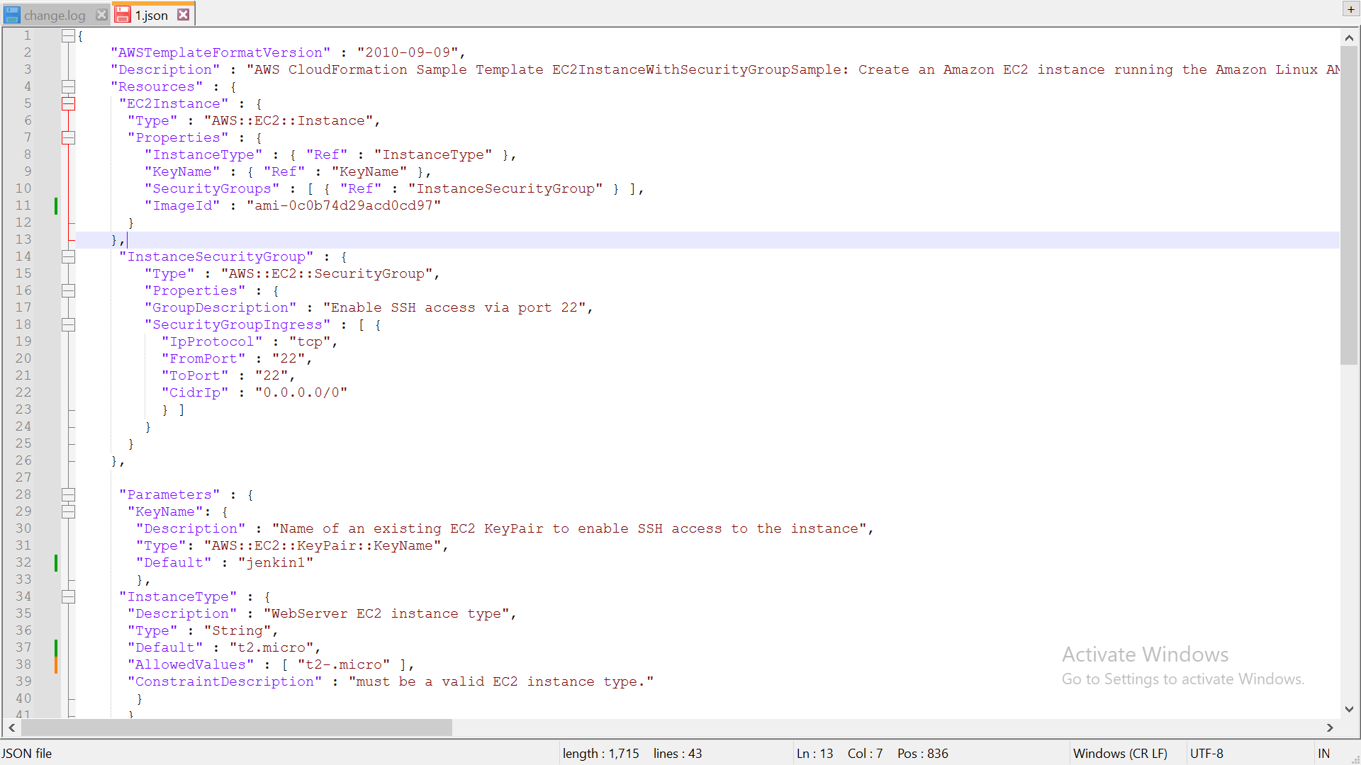

**5.**Click on choose file upload Json file and click on next

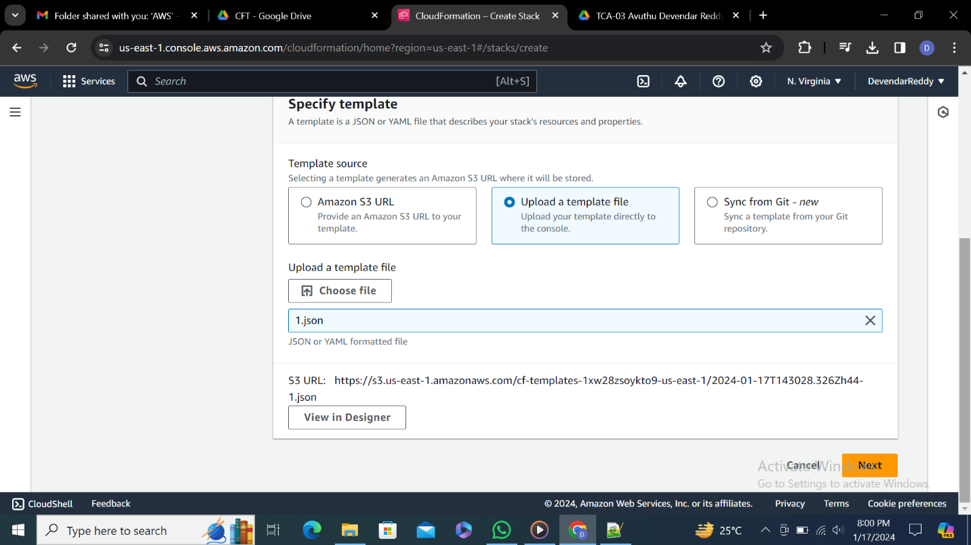

**6.**Enter a stack name 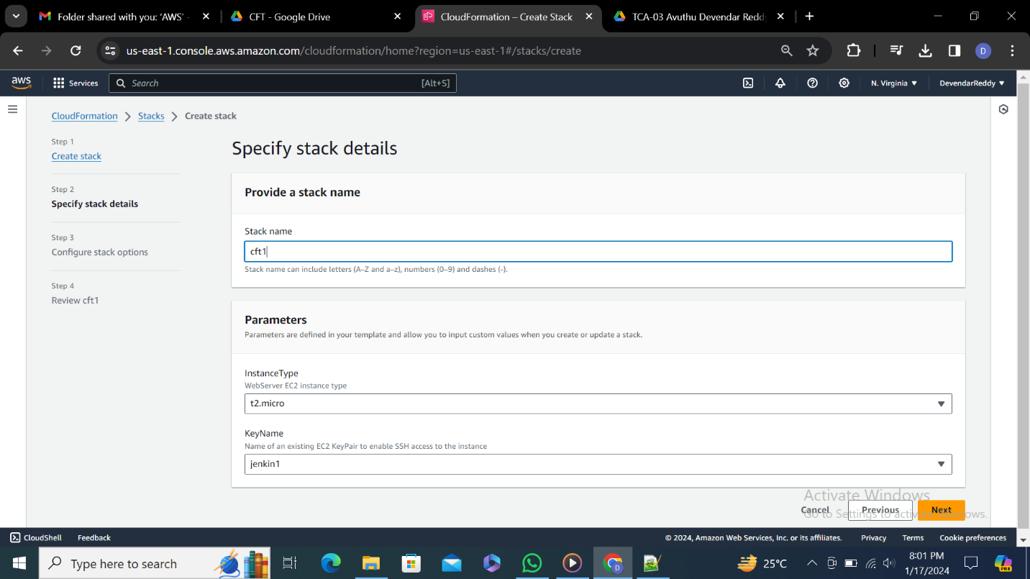

**7.**Make sure this setting are by default

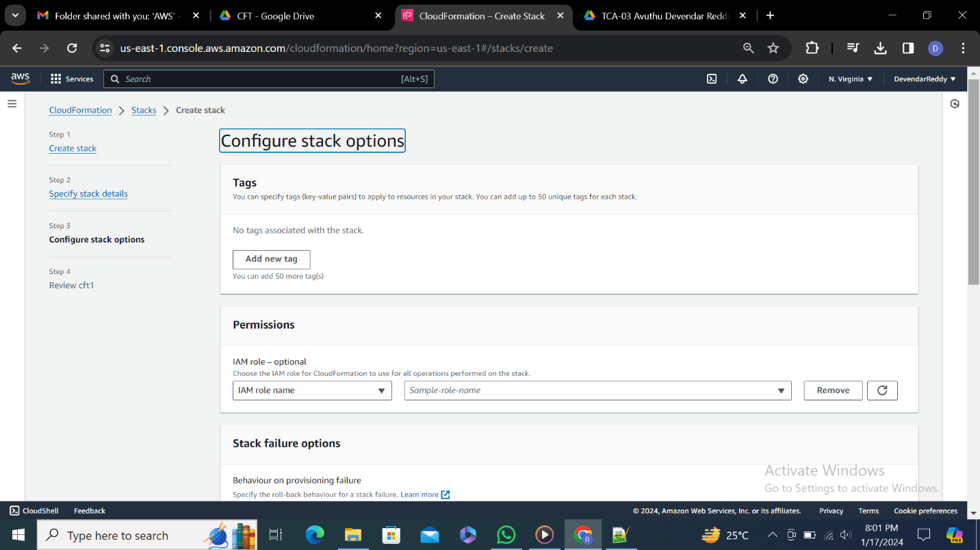

**8.**Select on roll back and use deletion policy

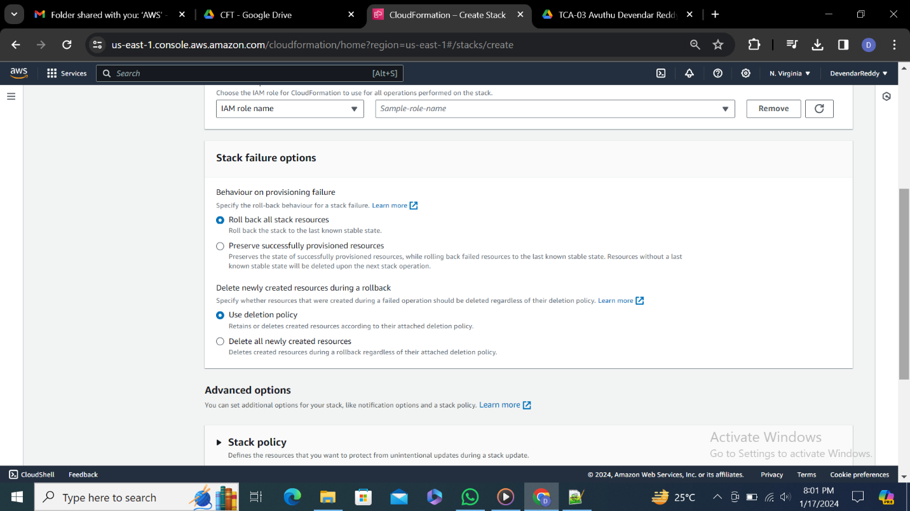

**9.**Setting are by default and click on next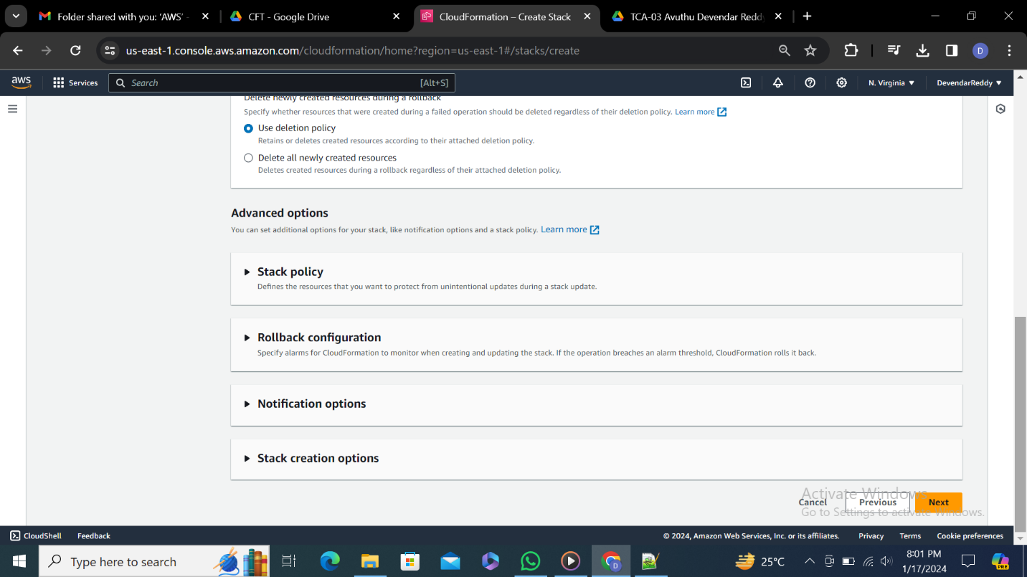

**10.**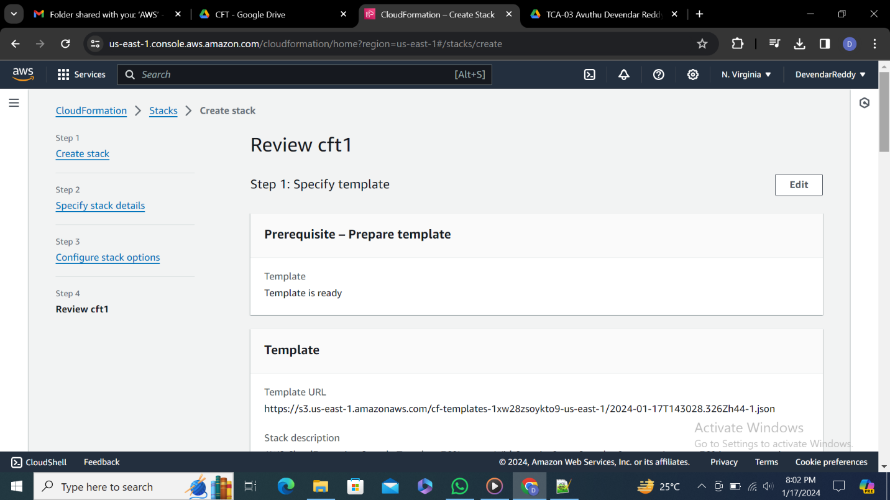

**11.**

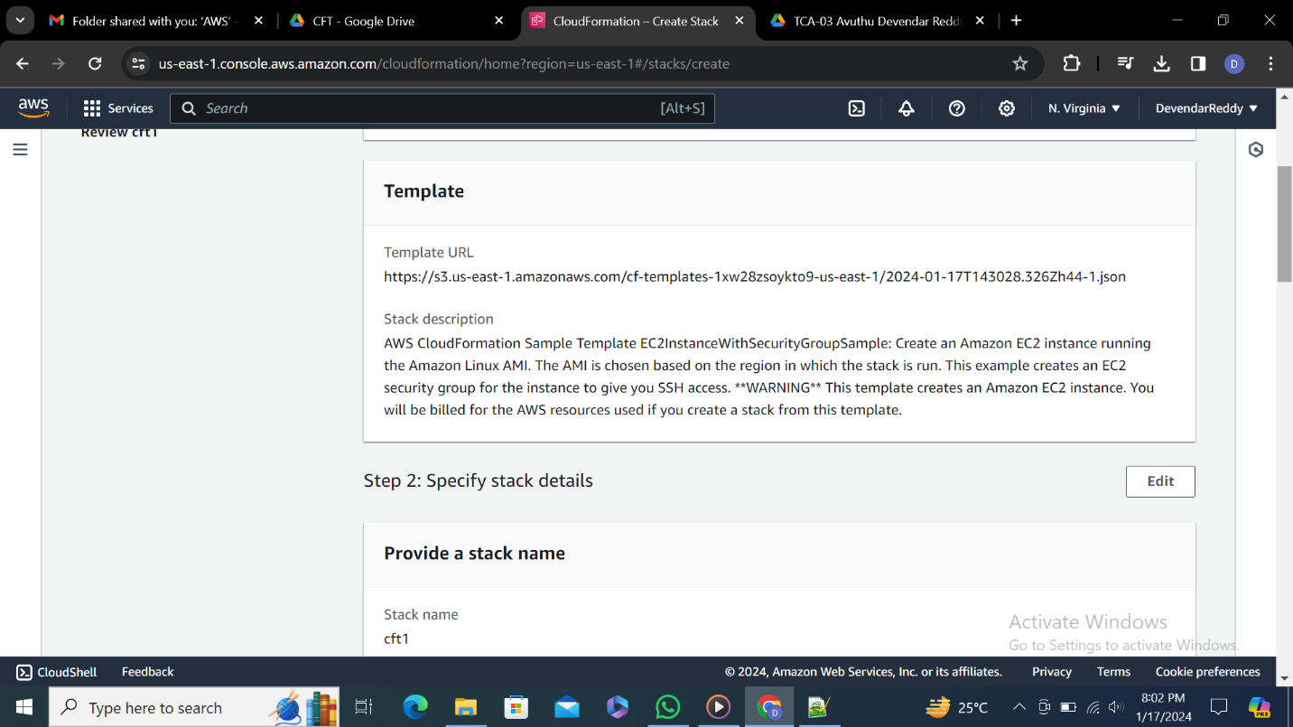

**12.**

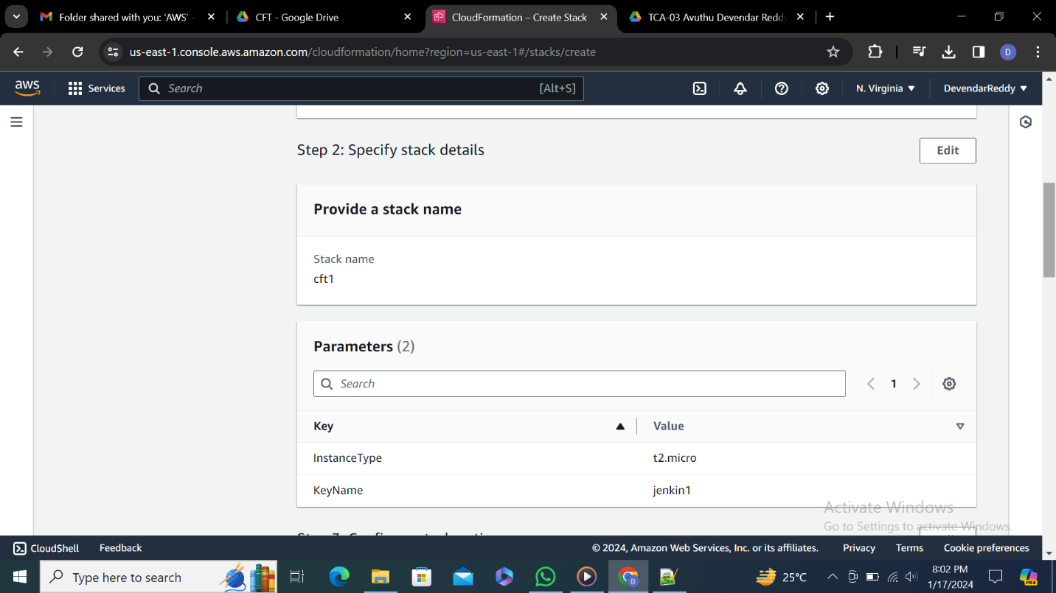

**13.**

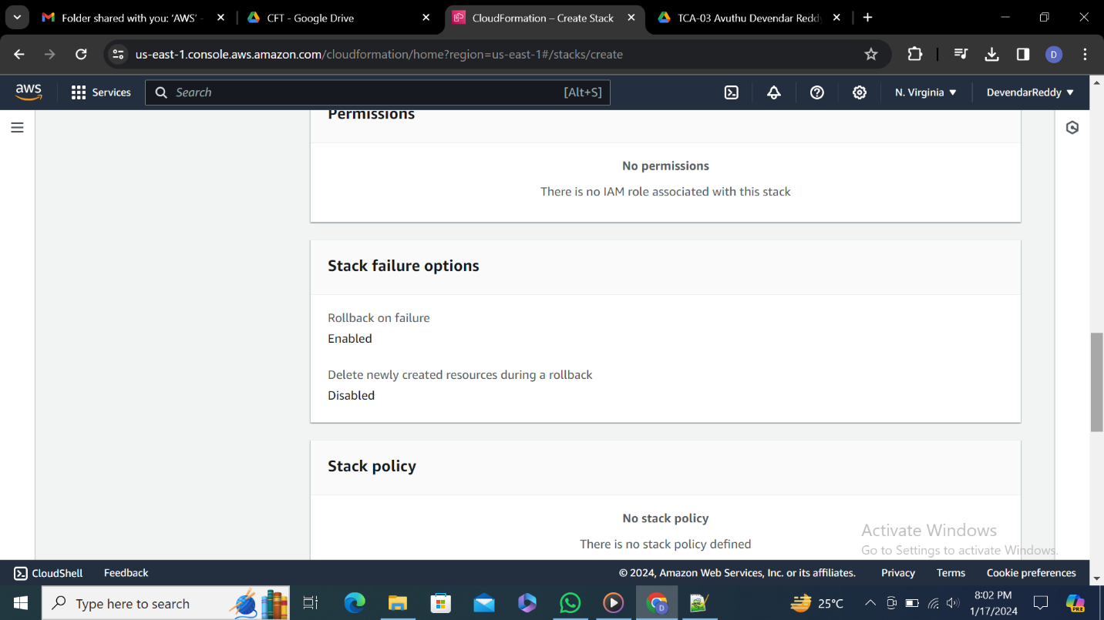

**14.**Click on submit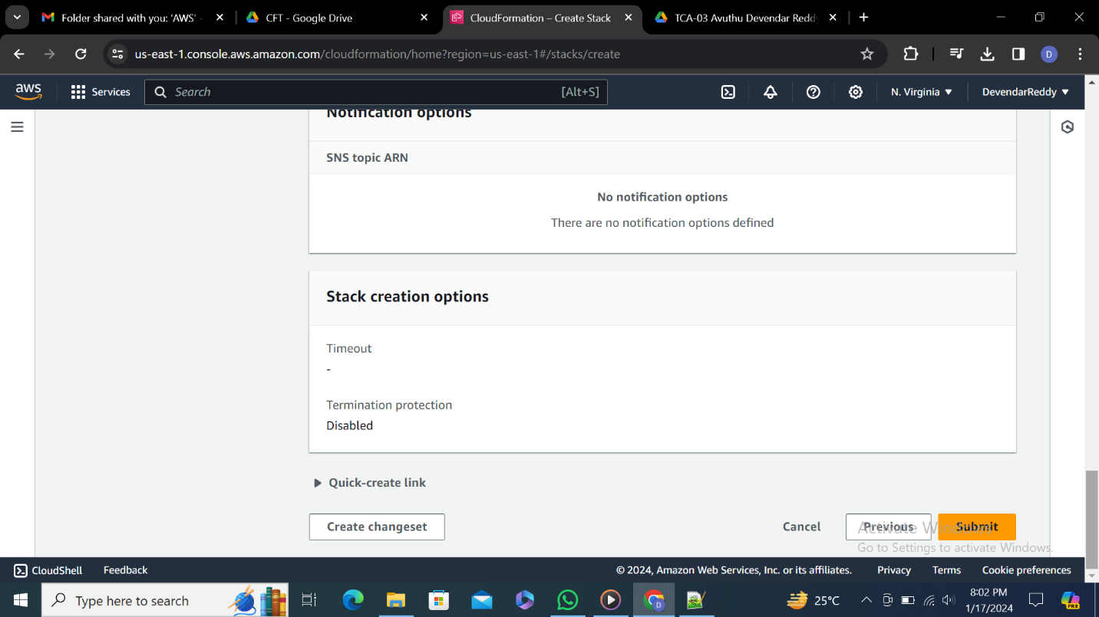

**15.**Stack is created and check status it should be create complete

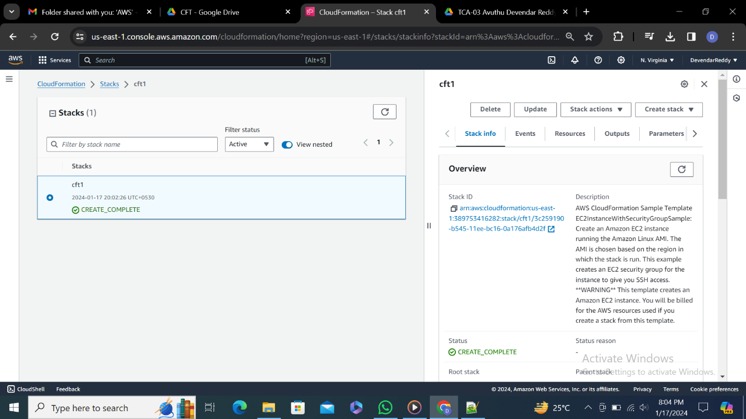

**16.**

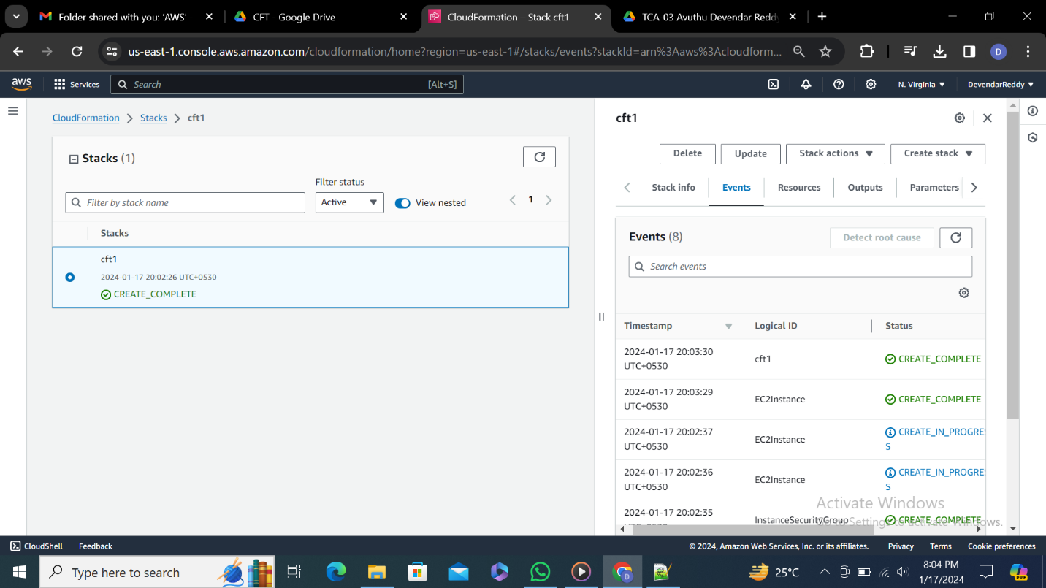

**17.**Go to instances check weather it is created or not.